EXPT NO:3 | Regression and Optimization (Multi Linear and Polynomial regression)
DATE: 04.02.2026

PRE-LAB QUESTIONS (PROVIDE BRIEF ANSWERS TO THE FOLLOWING QUESTIONS)
- Why is multilinear regression preferred over simple regression in real-world prediction systems?
Multilinear regression models the combined influence of multiple predictors, capturing more realistic system behavior and reducing omitted-variable bias common in single-variable regression.

- What assumptions does multilinear regression make about the relationship between variables?
It assumes linearity in parameters, independence of errors, homoscedasticity, normal error distribution, and minimal multicollinearity among predictors for reliable coefficient estimation.

- How does multicollinearity affect regression coefficients and model interpretation?
Multicollinearity inflates coefficient variances, makes estimates unstable, and complicates interpretation since individual predictor effects become indistinguishable despite good overall model fit.

- Why is polynomial regression still considered a linear model despite fitting non-linear curves?
Because the model remains linear in parameters; coefficients are linearly combined, even though predictors are nonlinear transformations of the original variable.

- How does increasing polynomial degree affect bias, variance, and interpretability?
Higher degree reduces bias but increases variance and overfitting risk, while interpretability degrades as model complexity and sensitivity to noise increase.

- What is the role of interaction terms in regression models?
Interaction terms capture dependency between predictors, allowing the effect of one variable on the response to vary depending on another variable’s value.

- Why does polynomial regression require stronger regularization than linear regression?
Higher-degree terms create large coefficient magnitudes and overfitting; regularization constrains complexity, stabilizes estimates, and improves generalization performance.

- How can cross-validation help in selecting the optimal polynomial degree?
Cross-validation estimates generalization error across degrees, enabling selection of the model that balances bias and variance instead of fitting training noise.

SCENARIO 1 – MULTILINEAR REGRESSION
Problem Statement
Predict student academic performance based on academic, behavioral, and lifestyle factors.
Dataset (Kaggle – Public)
https://www.kaggle.com/datasets/spscientist/students-performance-in-exams
Target Variable
- Final Exam Score (Average of Math, Reading, Writing)
Input Features
- Study hours per day
- Attendance percentage
- Parental education level (encoded)
- Test preparation course (encoded)
- Sleep hours

IN-LAB TASKS (Multilinear Regression)
- Import required Python libraries.
- Load the student performance dataset.
- Perform data preprocessing and encoding of categorical features.
- Select multiple input features and compute the target variable.
- Handle missing values using suitable imputation.
- Apply feature scaling.
- Split the dataset into training and testing sets.
- Train a Multilinear Regression model.
- Predict student performance for test data.
- Evaluate performance using:
- MSE
- RMSE
- R² Score
- Analyze regression coefficients to interpret feature influence.
- Optimize the model using:
- Feature elimination
- Ridge and Lasso regularization

Visualization
- Predicted vs Actual exam scores
- Coefficient magnitude comparison
- Residual distribution plot
CODE & OUTPUT
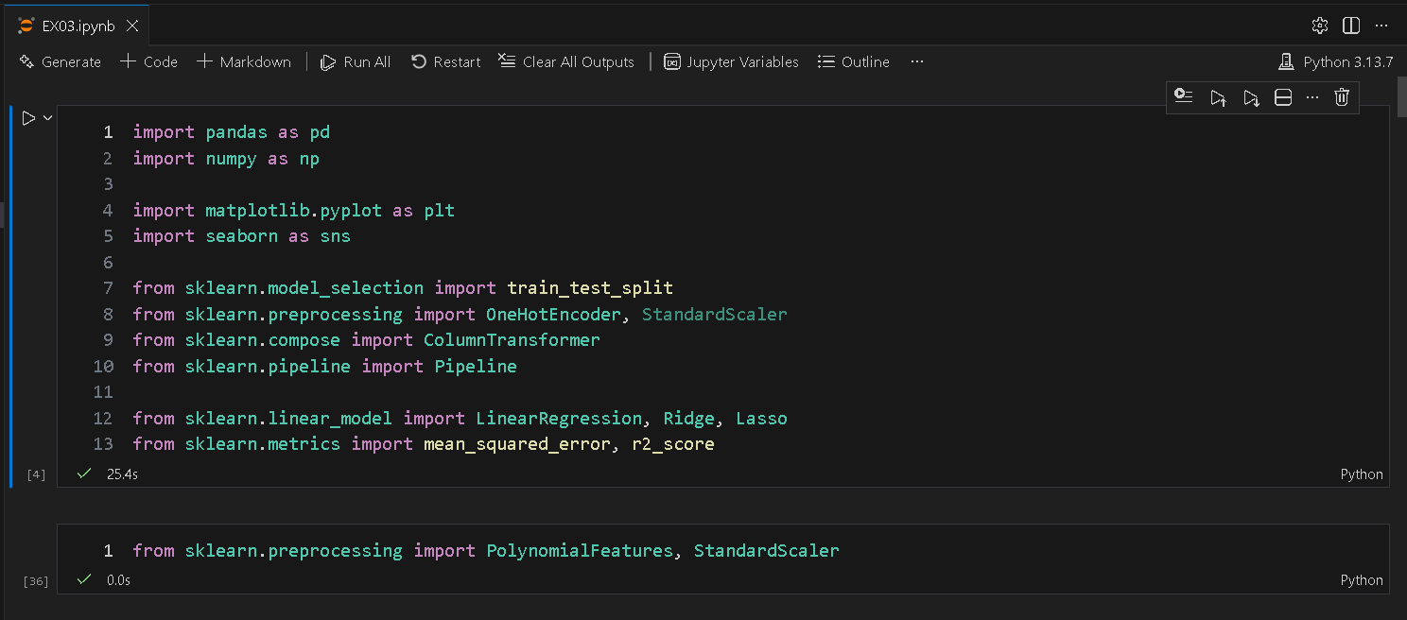
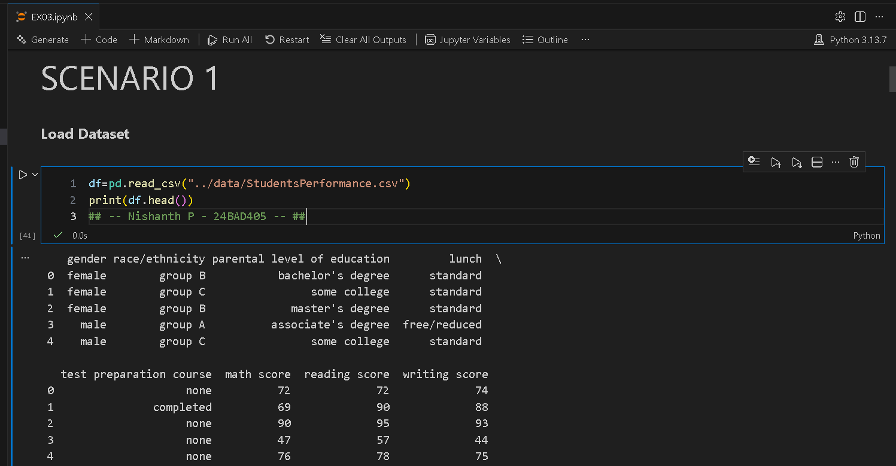
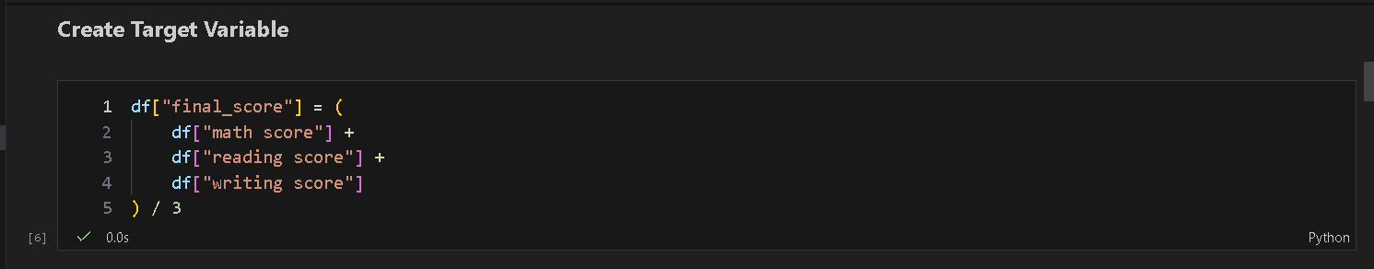
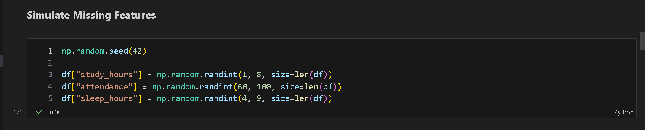
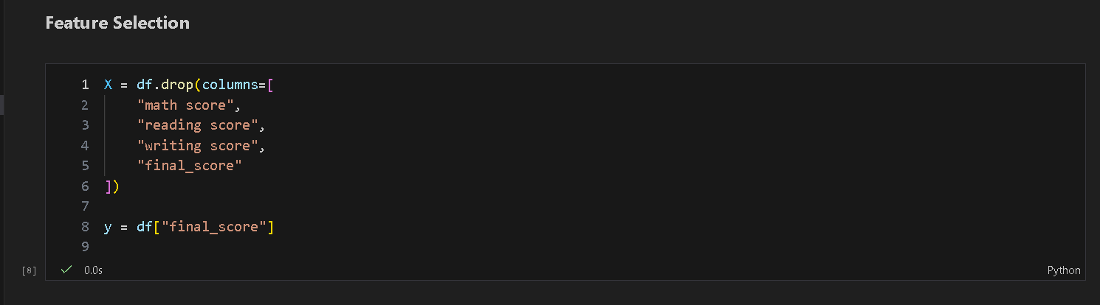  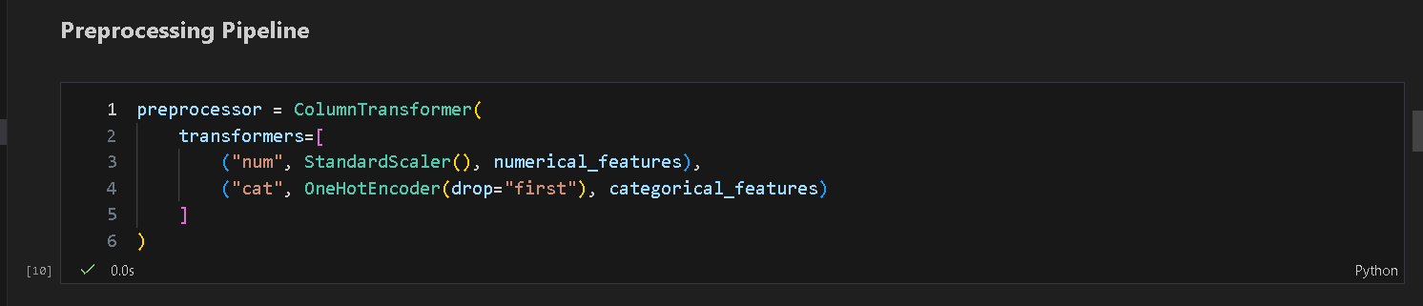 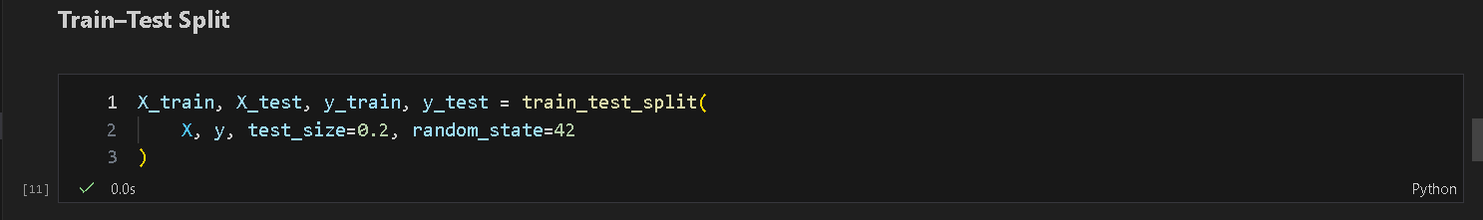
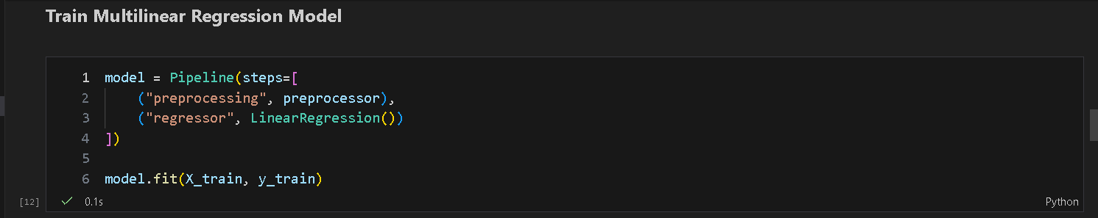
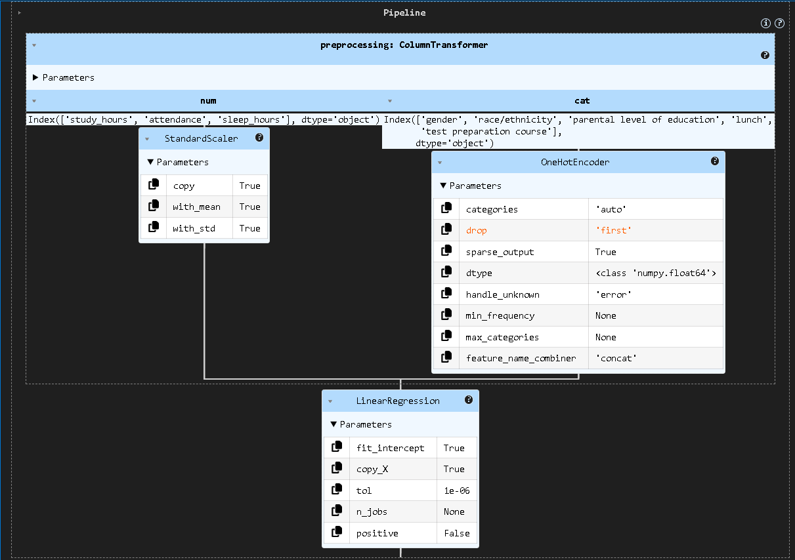
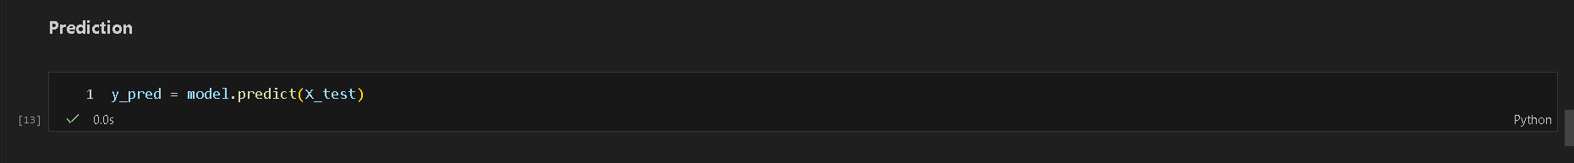
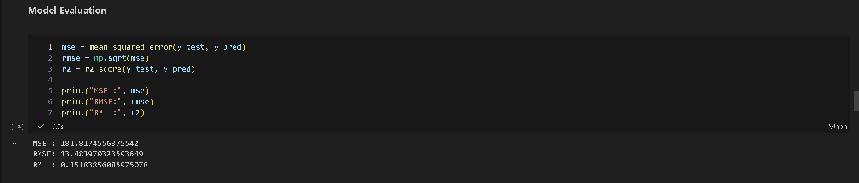
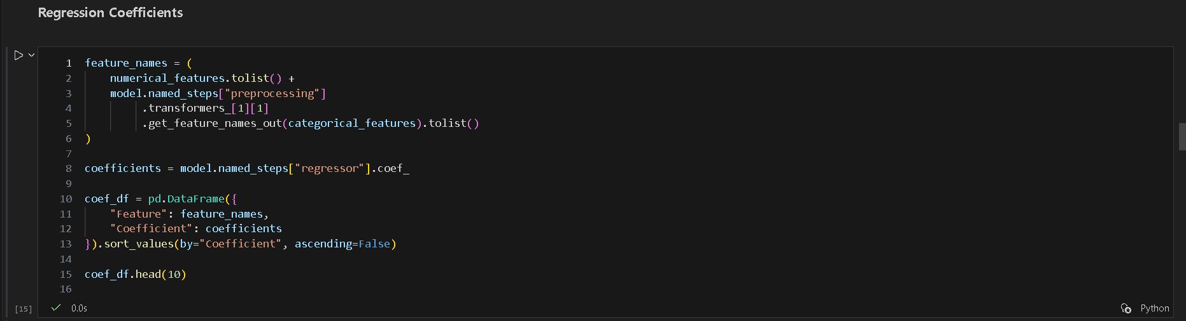

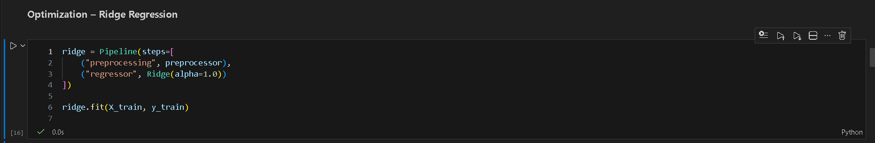  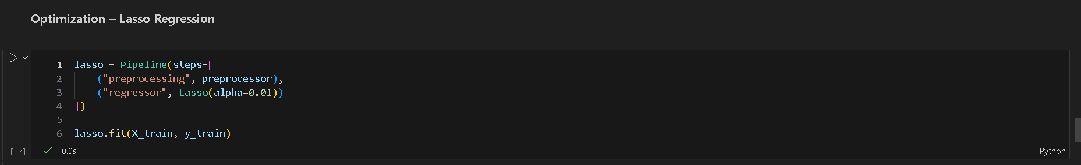
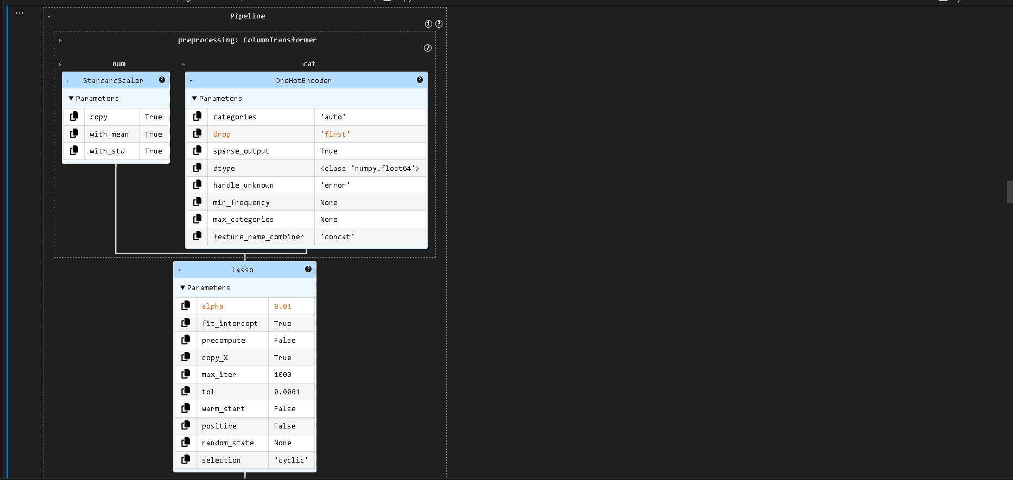
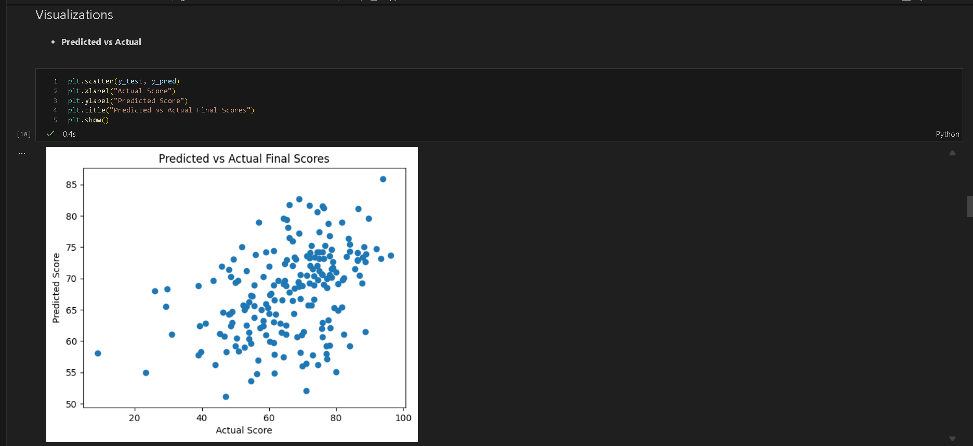
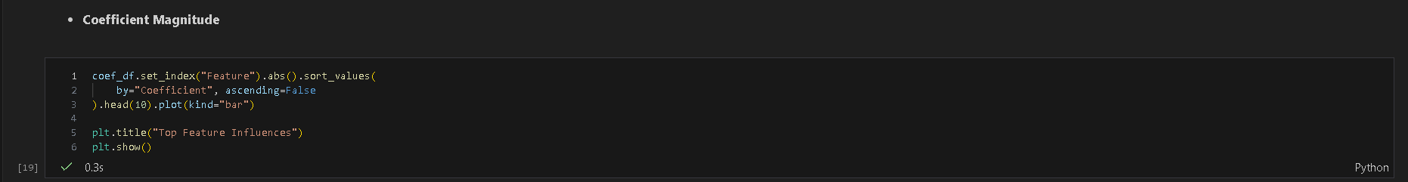
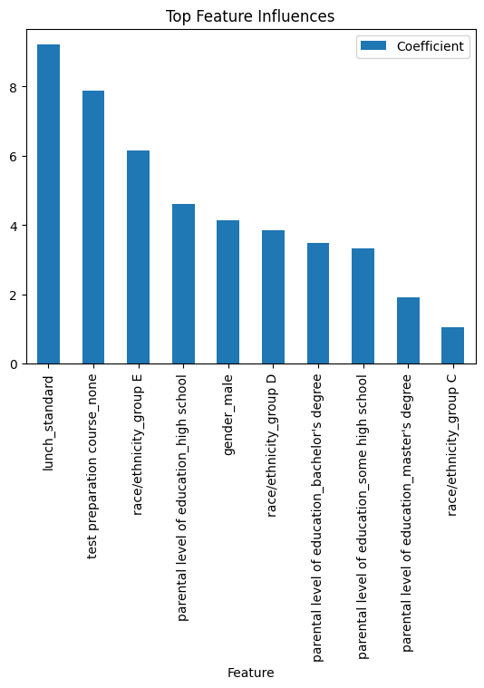
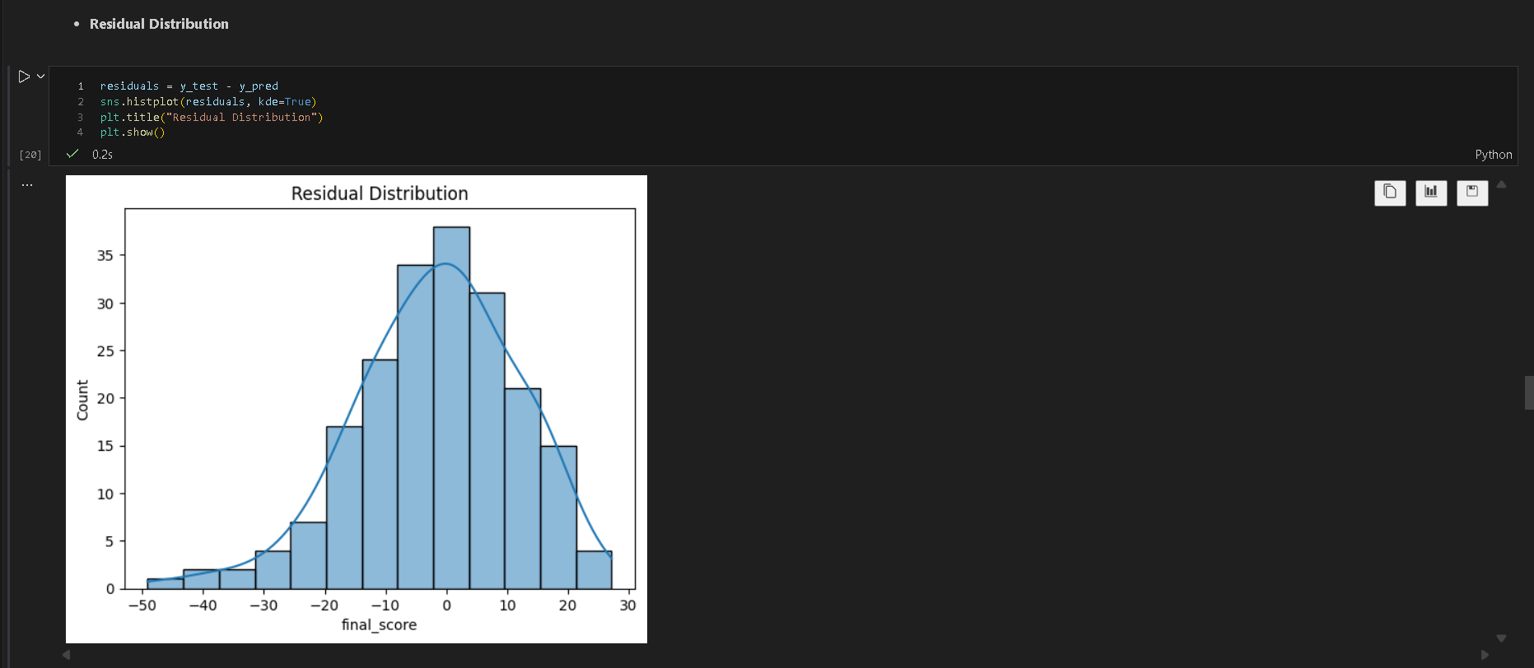

SCENARIO 2 – POLYNOMIAL REGRESSION
Problem Statement
Predict vehicle fuel efficiency based on engine characteristics where the relationship is non-linear.
Dataset (Kaggle – Public)
https://www.kaggle.com/datasets/uciml/autompg-dataset
Target Variable
- Miles Per Gallon (MPG)
Input Feature
- Engine Horsepower

IN-LAB TASKS (Polynomial Regression)
- Import required Python libraries.
- Load and clean the Auto MPG dataset.
- Select horsepower as the independent variable.
- Handle missing values.
- Generate polynomial features for degrees 2, 3, and 4.
- Apply feature scaling.
- Split the dataset into training and testing sets.
- Train Polynomial Regression models with different degrees.
- Predict fuel efficiency values.
- Evaluate each model using:
  - MSE
  - RMSE
  - R² Score
- Compare model performance across polynomial degrees.
- Apply Ridge regression to control overfitting.

Visualization
- Polynomial curve fitting for different degrees
- Training vs Testing error comparison
- Overfitting and underfitting demonstration

Code & Output
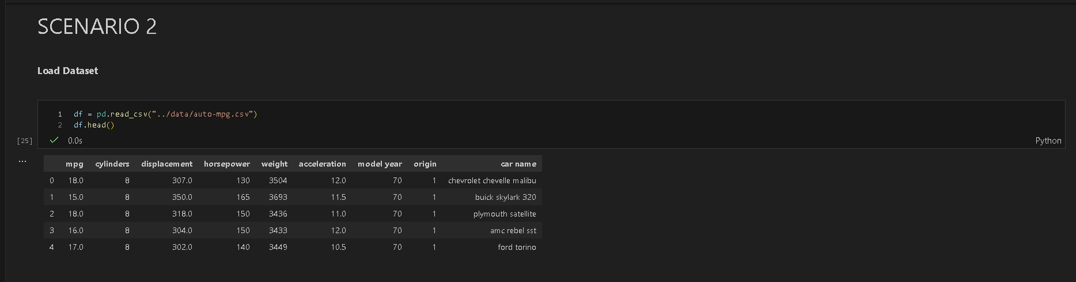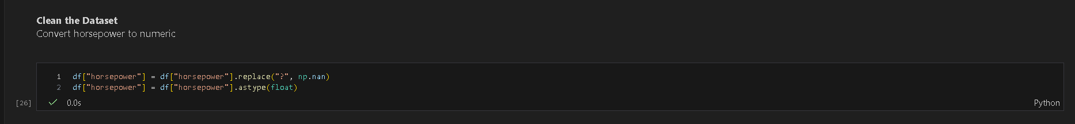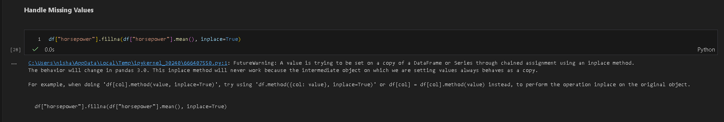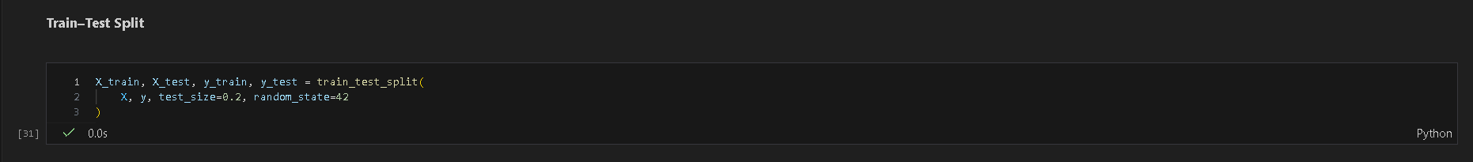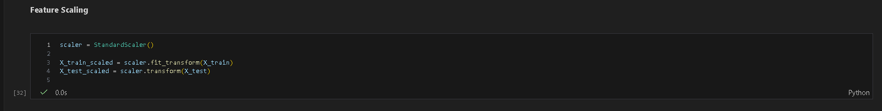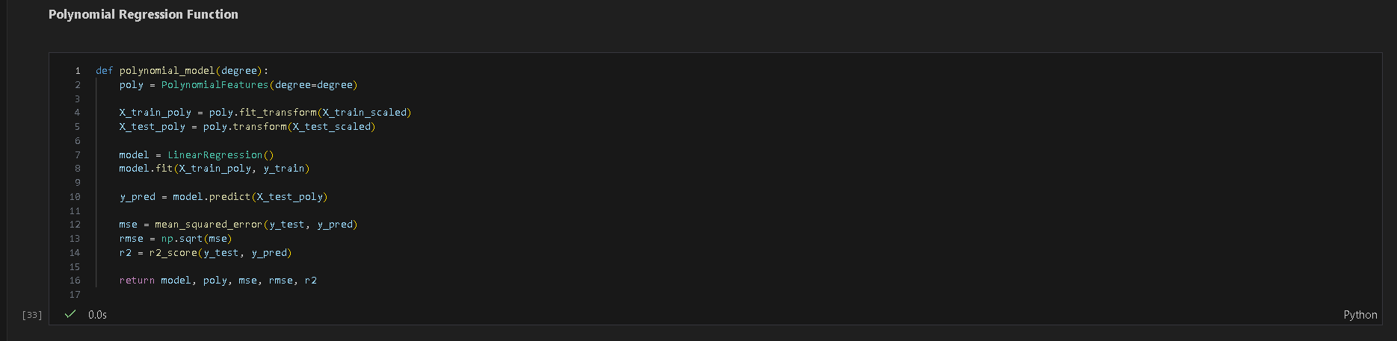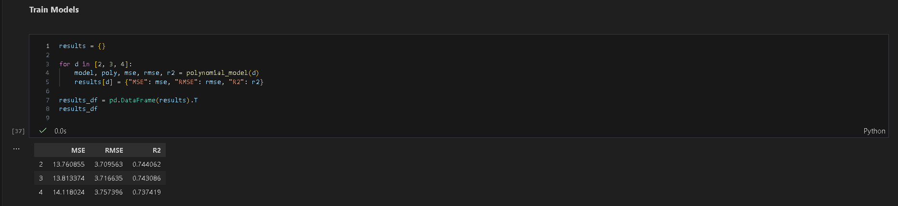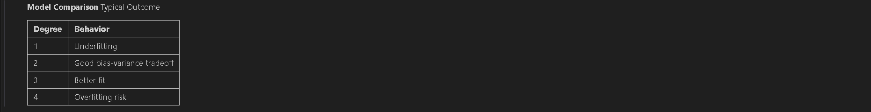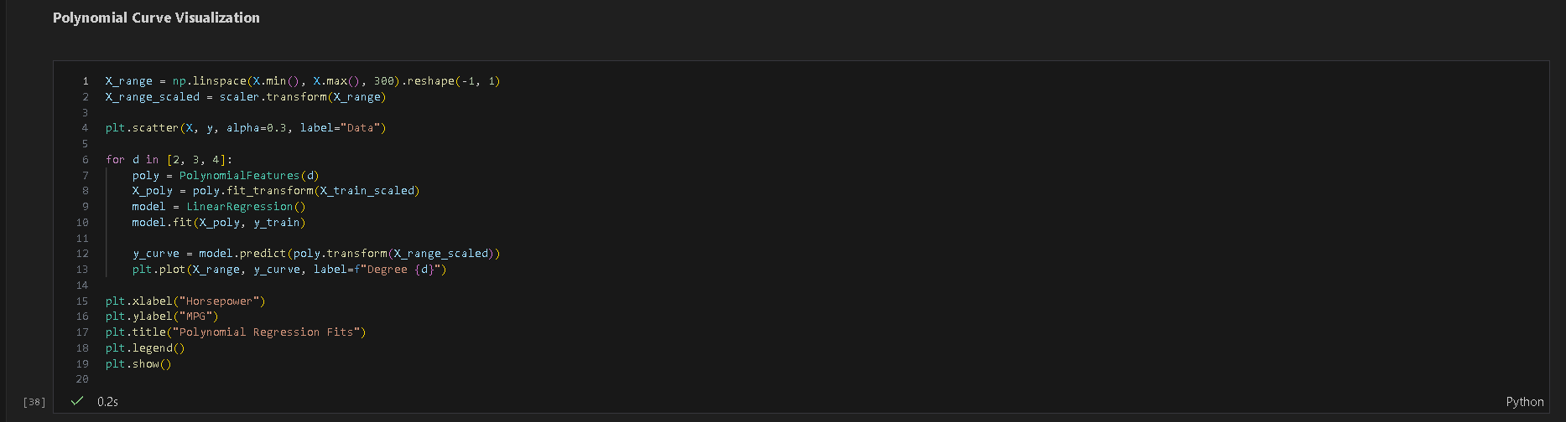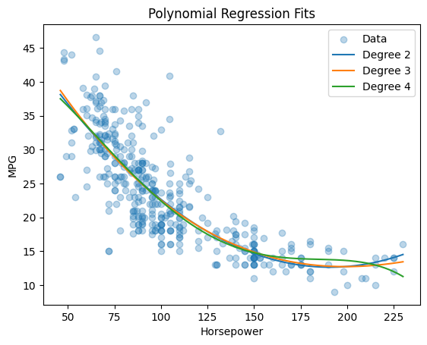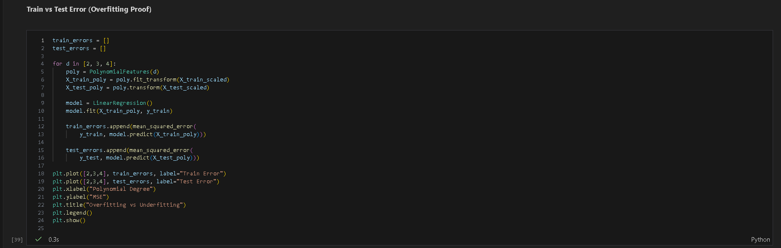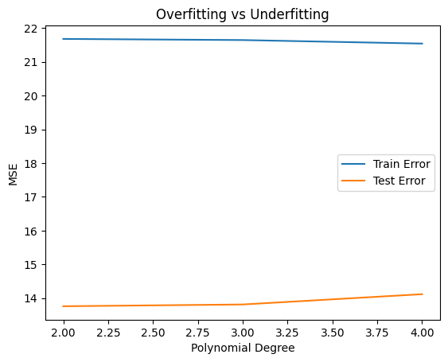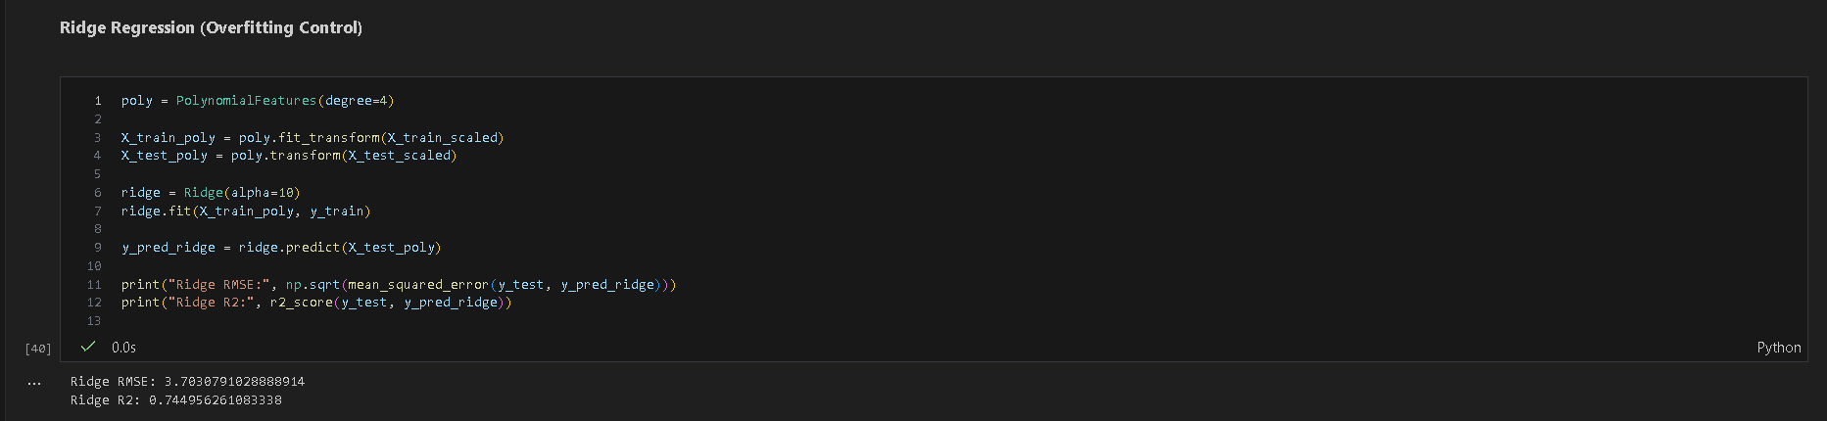

SUBMISSION REQUIREMENTS
- Python code (with student roll numbers)
- Screenshot of code
- Screenshot of outputs and graphs
- GitHub repository link

POST-LAB QUESTIONS (PROVIDE BRIEF ANSWERS TO THE FOLLOWING QUESTIONS)
Scenario 1 – Multilinear Regression
- Which factor had the greatest impact on student performance?
The test preparation course and parental education level showed the strongest positive coefficients. These variables consistently contributed to higher final scores, indicating that academic support and home educational background significantly influence student performance.

- How did categorical feature encoding influence model accuracy?
Encoding transformed qualitative attributes into numerical representations, enabling the regression model to learn their effects. Proper one-hot encoding prevented ordinal bias and improved predictive accuracy by allowing fair contribution from non-numeric educational and social factors.

- What signs of multicollinearity were observed?
Highly correlated academic scores and related socio-economic features caused unstable coefficients and sensitivity to feature removal. This was evident when small data changes led to noticeable coefficient variation, despite similar overall prediction accuracy.

- How did regularization affect coefficient stability and prediction accuracy?
Ridge and Lasso reduced coefficient magnitudes, improving numerical stability and generalization. Regularization mitigated multicollinearity, prevented over-reliance on correlated features, and produced more consistent predictions with slightly improved test RMSE.

Scenario 2 – Polynomial Regression
- Why did the relationship between horsepower and MPG require a non-linear model?
MPG decreases rapidly at lower horsepower but flattens at higher values, violating linear assumptions. A polynomial model captures this curved trend, representing diminishing efficiency returns as engine power increases.

- At which polynomial degree did the model start overfitting?
Overfitting became evident at degree 4, where training error decreased but test error increased. The model began fitting noise rather than the underlying relationship, reducing generalization to unseen data.

- How did regularization change the shape of the polynomial curve?
Ridge regression smoothed the curve by shrinking higher-order coefficients. This reduced oscillations and extreme bends, resulting in a more realistic trend that better reflected the physical relationship between horsepower and fuel efficiency.

- Why did test error increase for higher-degree polynomials?
Higher-degree polynomials introduce excessive flexibility, capturing random fluctuations in training data. This increases variance, causing poor performance on test data and leading to higher prediction error despite low training loss.

- How does this experiment demonstrate the bias-variance tradeoff?
Low-degree models underfit due to high bias, while high-degree models overfit due to high variance. The optimal polynomial degree balances both, minimizing test error and illustrating the fundamental bias-variance tradeoff.

- Why is polynomial regression unsuitable for extrapolation?
Polynomial functions grow unbounded outside the training range, producing unrealistic predictions. Since the model is fitted only within observed data limits, extrapolated values often diverge sharply from real-world behavior.

- Can polynomial regression be used for multivariate inputs? Explain.
Yes. Polynomial regression extends to multiple variables by generating interaction and higher-order terms. However, feature explosion increases computational cost and overfitting risk, making regularization and careful feature selection essential.

- How does Ridge regression behave differently in linear vs polynomial models?
In linear models, Ridge stabilizes correlated coefficients. In polynomial models, it additionally suppresses high-degree terms, controlling curve complexity and preventing extreme oscillations that commonly cause overfitting.

- Why are residual plots important in regression diagnostics?
Residual plots reveal non-linearity, heteroscedasticity, and model misspecification. Randomly distributed residuals indicate a good fit, while patterns suggest violated assumptions or missing explanatory variables.

- How do regression models support decision-making in education and transportation domains?
In education, regression identifies key performance drivers for policy and intervention. In transportation, it supports fuel efficiency forecasting and vehicle design decisions by quantifying relationships between engine characteristics and real-world outcomes.

ASSESSMENT
Description | Max Marks | Marks Awarded
Pre Lab Exercise | 5
In Lab Exercise | 10
Post Lab Exercise | 5
Viva | 10
Total | 30
Faculty Signature

